Waves
You should have a main page title Waves on Weekly.

Use the following link to find information: (There are 4 lessons on this page)
http://www.physicsclassroom.com/class/waves
I have narrowed down to what you need to know for each lesson and should be on your Weekly page.
Lesson 1
- What is a wave?
A disturbance that repeats up space bad tune bad that is transmitted progressively from one place to the next with no actual transport of matter.
- What are the different categories of waves? Give examples of each type. (pg. 497 in the book is helpful for this)
Transverse-Electromagnetic Waves
Longitudinal-Sound Waves

Lesson 2
- Define wavelength of a wave and then get a picture from the web of what a wavelength is.
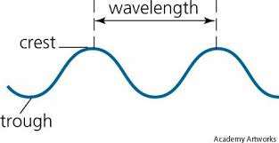
The distance from the top of the crest, or equivalently, the distance between successive, identical parts of the wave.
- Define frequency of a wave.
The number of events (cycles, vibrations, oscillations, or any repeated events) per time; measured in hertz (or events per time). Inverse of period.

Use this simulation to answer the next question: http://www.physicsclassroom.com/Physics-Interactives/Waves-and-Sound/Simple-Wave-Simulator/Simple-Wave-Simulator-Interactive
- What is the relationship between wavelength and frequency? Screen capture the interactive to show the relationship between wavelength and frequency.
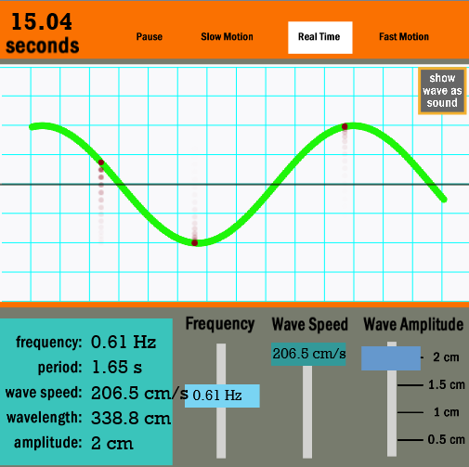
Lesson 3
- What are constructive and destructive waves? ** For this question, instead of using the website, use page 498 in the book.
Constructive- The crest of one wave overlaps the crest of another and their individual effects add together.
Destructive- The crest of one wave overlaps the trough of another and their individual effects are reduced.

- What is Doppler Effect? Provide a real life example.
The apparent change of frequency due to the motion of the source (or receiver) – The sound of a car horn.

Lesson 4 - You do not need any information

Electromagnetic waves

